Haynes, Christopher David, Dr (from Linked In)
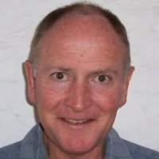

Graduated from Australian Forestry School in 1965. Charles Darwin University PhD, Anthropology 2004 – 2009 Thesis title: 'Defined by contradiction: the social construction of joint management in Kakadu National Park.
Worked initially in pine plantation forestry at Mount Gambier in South Australia 1965-69. With Forestry Section of the Northern Territory Administration in Darwin 1969-75. Forestry Adviser for the Maningrida Council in Arnhemland 1975-77. With Australian National Parks and Wildlife Service 1978-85, first as a project officer based in Canberra, then as park superintendent and project coordinator and, ultimately as an Assistant Director of the park service, based in Darwin.
In 1985 appointed Director of National Parks in Department of CALM W.A., holding this position until 1994 when became Director of Regional Services. Retired from full time work in 1997. Since 2009 has taught and tutored in anthropology and sociology at the University of Western Australia and consulted in land management use and anthropology in both WA and the NT.

Honorary Research Fellow University of Western Australia March 2010 – . In the Discipline of Anthropology and Sociology. Currently working on writing up work for academic journals. Also assists in a number of university roles: student supervision, teaching and examining.

Associate Resolve GLobal Pty Ltd November 2009 – July 2012. Park Manager, Kakadu National Park Parks Australia April 2002 – April 2004. Consultant, Northern Land Council, Darwin April 2012 – May 2012

